SQLLABDAY8 ASSIGNMENT

1.Create 2 triggers on emp table .

Trigger 1:

Before inserting any new record on emp table. In the trigger body capture the action done in emp table into another table named emplog having columns (serialno int autoincrement, action varchar(100),actiondate_time datetime) Serialno column to be incremented automatically and action to be ‘New Record Added to emp’ and actiondate_time should be current date and time

Code For Trigger 1:-

use demo;

create table emplog ( serialno int auto_increment primary key , actions varchar(200) , action_datetime datetime);

alter table emplog auto_increment=100;

insert into employee(Emp_id,emp_name,job_name,salary,commission,dept_id) values(29,'Sam','Administrator',100000,1000,1);

delimiter $

drop trigger if exists empupdate;

create trigger empupdate before insert on employee

for each row

begin

insert into emplog (actions, action_datetime) values('Inserted',now());

end $

delimiter ;

select * from emplog;

Trigger 2:

After deleting any record from emp table. Trigger body add record in emplog table with action ‘Record deleted from EMP’. serialno autoincrement and actiondate_time should be current date and time

Code for Trigger 2:-

delete from employee where Emp_id=28;

delimiter $

drop trigger if exists deleteemp;

create trigger deleteemp after delete on employee

for each row

begin

insert into emplog (actions, action_datetime) values('Deleted',now());

end $

delimiter ;

select * from emplog;

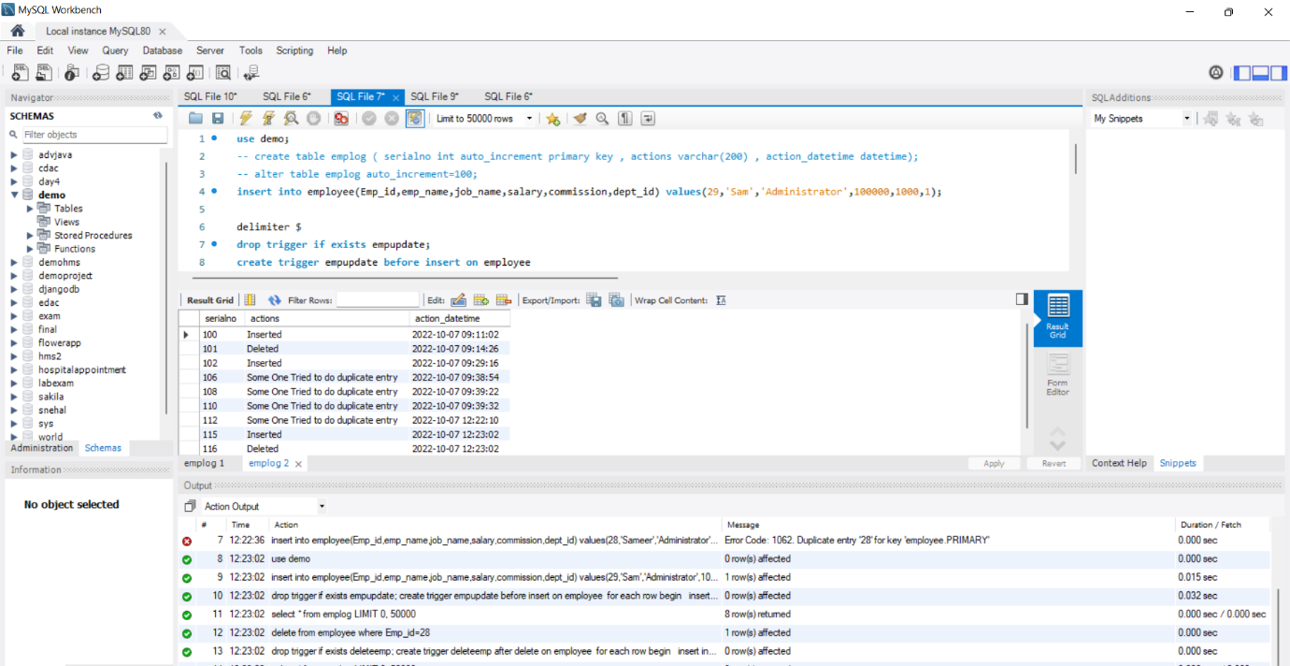

2. Try to capture exception handling in insert trigger such that no

duplicate record to be added. Add that action also to emplog table with action ‘Trying to add

duplicate record’

Code :-

/* Exception handler for table not found */

use demo;

DROP PROCEDURE IF EXISTS TestProc;

DELIMITER $$

CREATE PROCEDURE TestProc()

BEGIN

DECLARE Duplicate_entry CONDITION for 1062 ;

DECLARE EXIT HANDLER FOR Duplicate_entry

SELECT 'Same Data Present In table' Message;

insert into emplog(actions,action_datetime) values('Some One Tried to do duplicate entry',now());

insert into employee(Emp_id,emp_name,job_name,salary,commission,dept_id) values(28,'Sameer','Administrator',100000,1000,1);

END$$

DELIMITER ;

call TestProc();

select * from emplog;

